**Amazon Products Case Study**

**Analysis & Dashboard Report**

**Dataset Summary:** Product listings with fields such as product category levels, prices (discounted & actual), ratings, reviews, revenue, and score metrics.

**Analysis Task**

**Key Tasks and Insights**

**1. Average Discount Percentage by Product Category**

Analysing the average discount per category helps understand:

* Which product types receive the most discounts.
* Potential markdown strategies and pricing inefficiencies.
* Which also show that Home Improvement category has the highest average discount percentage and Toy and Games have 0%.



**2. Number of Products Listed Under Each Category**

This provides a clear view of category density and diversity.

Electronics Category has the highest number of products followed by Home and Kitchen Category. While Car & Motorbike, Health & Personal Care and Toy & Care Category have the least (1)



**3. Total Number of Reviews per Category**

Reviews reflect both customer interaction and satisfaction.

Electronics have highest total number of reviews per category and Health & Personal Care has the lowest. A category with high sales but few reviews may need better post-purchase engagement strategies.



**4. Average Rating by Product**

Ratings are essential indicators of product quality and customer perception. 

**5. The average of actual price vs the discounted price by category**

The Electronics Category led in both average.



**6. Products with the highest number of reviews.**

The table shows the top 5 products with the highest number of reviews in order.



**7. Number Products with Discount ≥ 50%**

This task identifies aggressive discounting patterns. There are **662 products.**

**8. The distribution of product ratings (e.g., how many products are rated 3.0, 4.0, etc.)**



**9.** **Revenue Contribution by Product Category**

Revenue analysis highlights top-performing categories and helps optimize inventory. Electronics contribute more the revenue than any other categories with Toy & Games being the last.



**10. The number of unique products per price range bucket.**

This is showing the number unique products per price range.



**11. How does the rating relate to the level of discount?**

**Interpretation:** It is a weak correlation.

* + Slope is negative, 1 unit increase in discount, the rating drops by 0.226
  + As Discount increases, ratings slightly decrease.
  + But the relationship is not strong, the effect is small.
  + R^2 is 0.0262, there is downward trend, discount is not a strong predictor of rating
  + This could be due to product quality, clearance items, or user expectation.

**12. Products that have fewer than 1,000 reviews**

There are **309 Products** that have fewer than 1,000 reviews.

**13. Categories that have products with the highest discounts.**

Computer & Accessories have the product with the highest discounts follows Electronics Categories.



**14. Identify the top 5 products in terms of rating and number of reviews combined.**

A custom score field helps rank products based on a combination of price, reviews, and ratings.  
Products with high scores and high revenue can be used in upsell campaigns.



**Dashboard**

**Key Tasks and Insights**

**KPI Cards**

* Total Revenue is **₹ 68,948,110,719.13**
* Average Discount % is **47%**
* Average Rating is **4.09%**
* Number of Products is **1350**

**Slicers (Filters)**

* Product Category (**Category**)
* Discount <= 50%
* Price Buckets

These allow users to filter the data dynamically and view performance

**DASHBOARD VIEW**

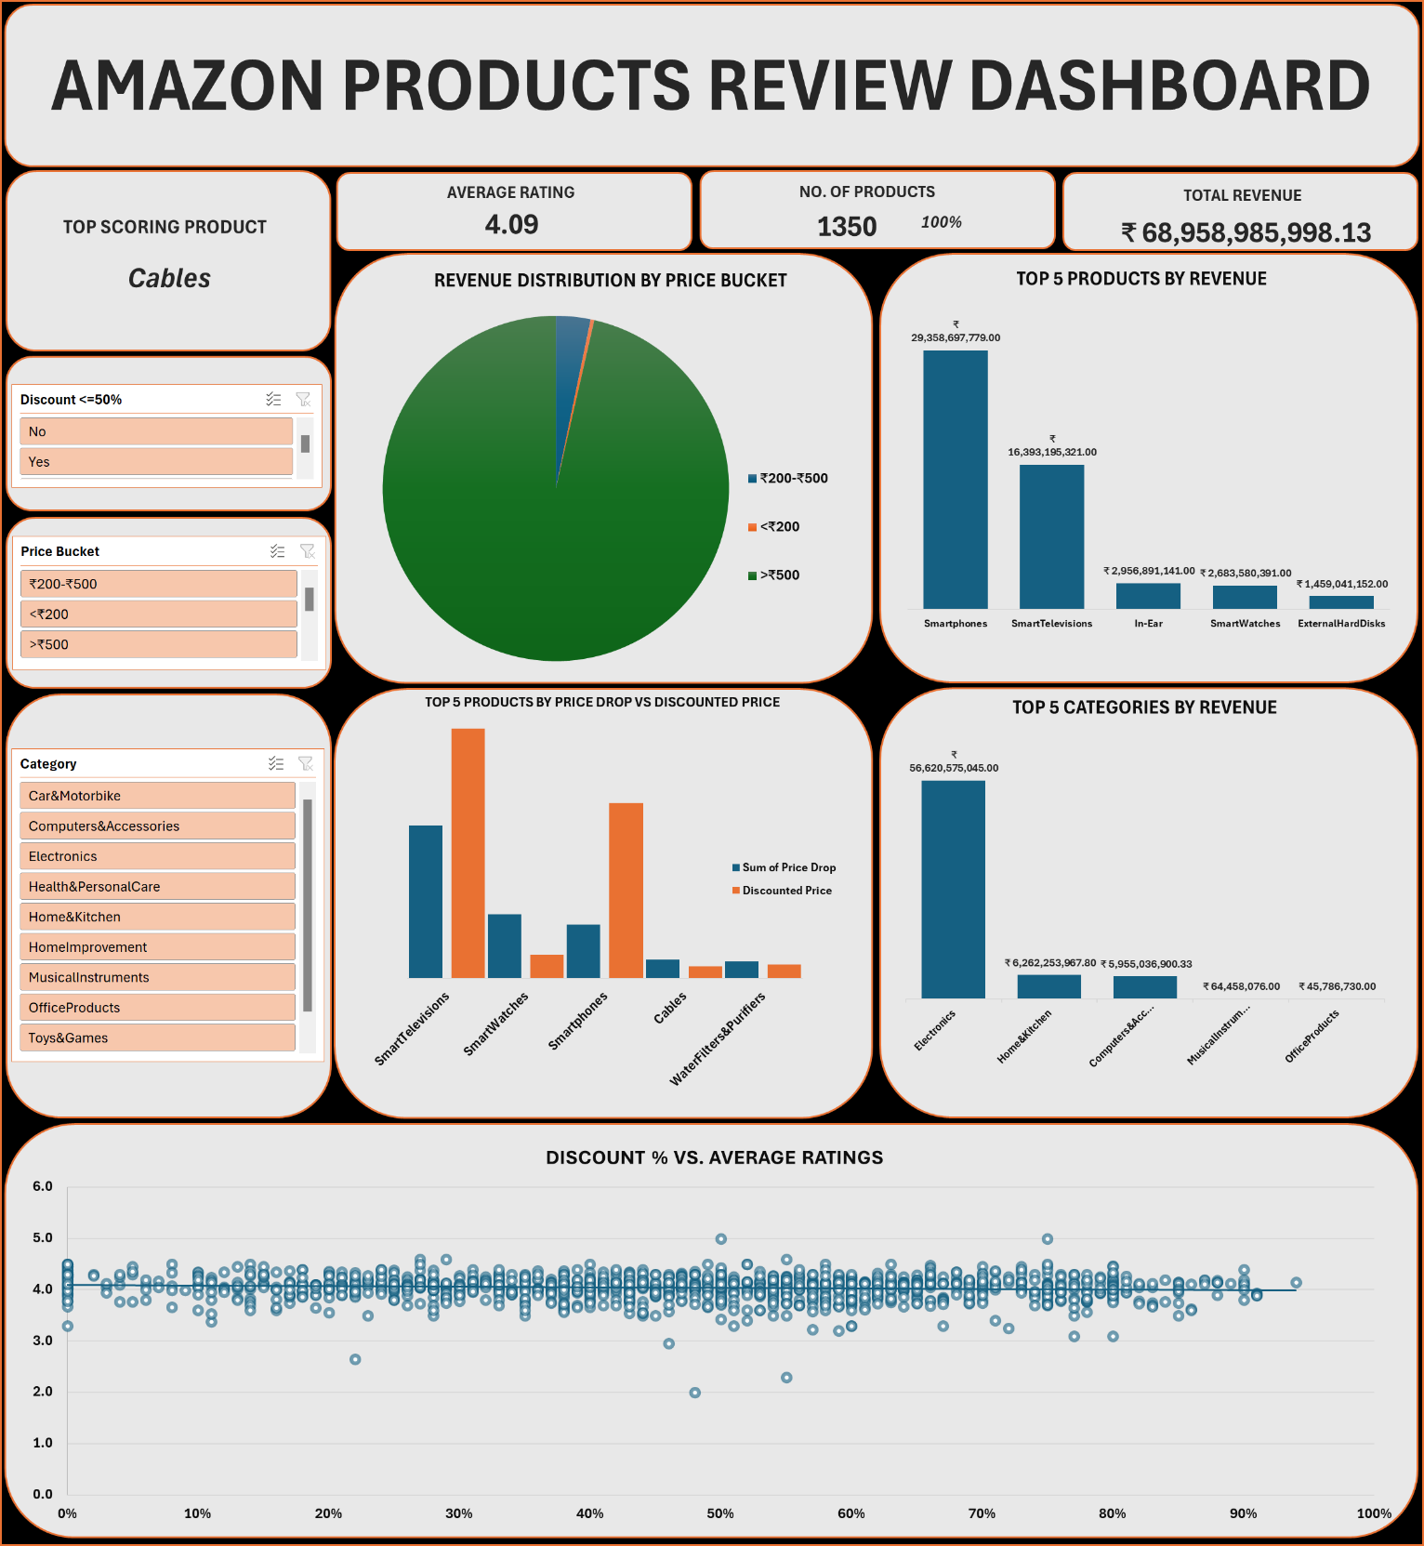

**TOP 5 PRODUCTS BY REVENUE**

These are the top 5 products in the chart, generated the highest revenue across the dataset, indicating strong customer demand and market performance. These products likely benefit from a combination of high sales volume, discounted price, or consistent customer satisfaction.

*Recommendation:*  
Prioritize these products in marketing campaigns, ensure inventory availability, and explore similar offerings to replicate success.

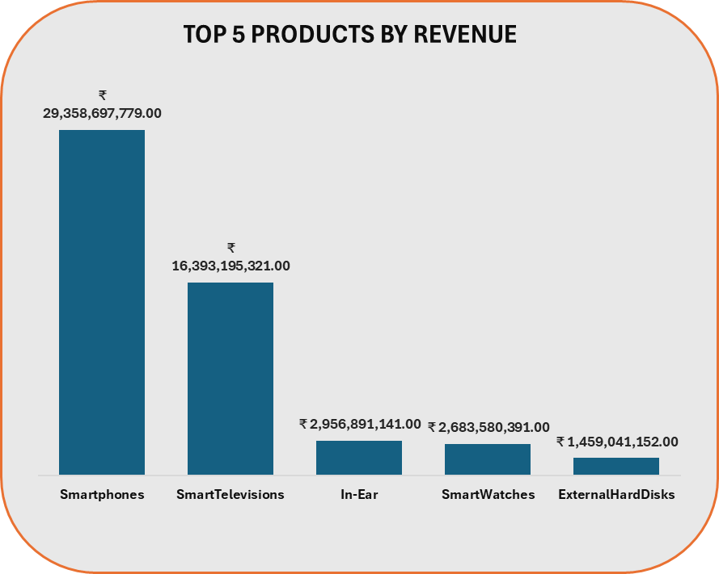

**TOP 5 PRODUCTS BY PRICE DROP VS DISCOUNTED PRICE**

The chart compares the sum of price drop against the discounted price for the top 5 product categories. Key observations:

* **Smart Televisions** and **Smart Watches** show the highest total price drops, suggesting significant markdowns to drive sales or clear inventory.
* **Smartphones** maintain a moderate price drop but have high discounted prices, possibly indicating premium positioning despite discounts.
* **Cables** and **Water Filters & Purifiers** show smaller drops and lower discounted prices, aligning with their lower price brackets.

*Recommendation:*  
Products like **Smart Televisions** and **Smart Watches** should be monitored for profitability. If deep discounts are routine, evaluate whether the volume justifies the margin loss. Consider bundling or value-based promotions instead of aggressive discounting.

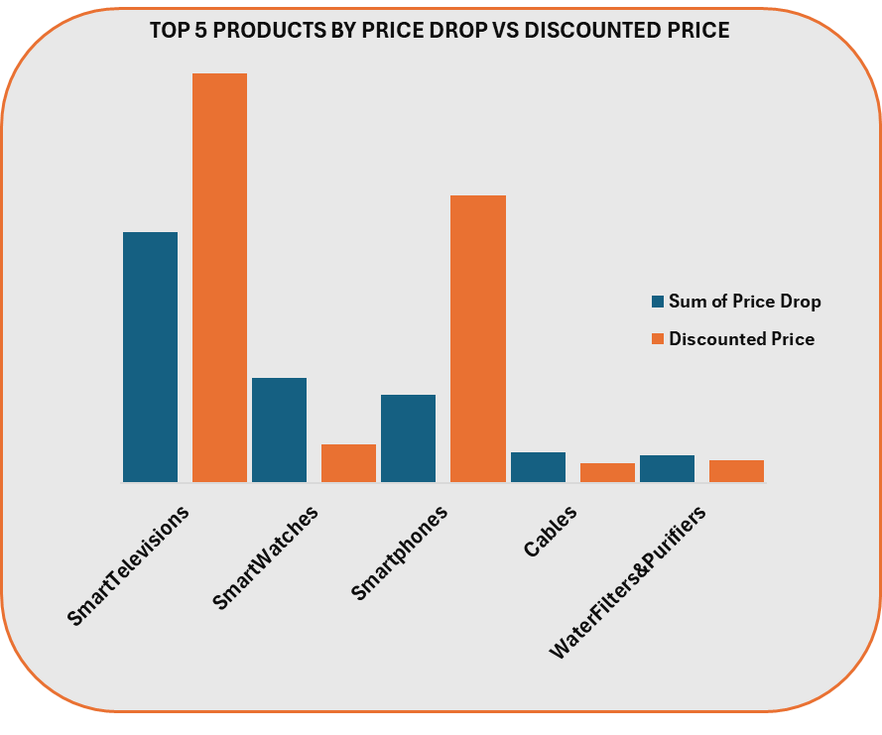

**TOP 5 CATEGORIES BY REVENUE**

The revenue distribution clearly highlights **Electronics** as the dominant category, generating over ₹56.6 billion — far outpacing all others. **Home & Kitchen** and **Computers & Accessories** follow distantly, while **Musical Instruments** and **Office Products** contribute minimal revenue in comparison.

*Key Observations:*

* **Electronics** alone drives the majority of total revenue.
* There’s a steep drop-off after the top category, indicating a highly skewed sales concentration.

*Recommendation:*

* Leverage the performance of Electronics with upselling and cross-selling strategies (e.g., pair with accessories).
* Explore ways to boost revenue in lower-performing categories through targeted promotions or product diversification.

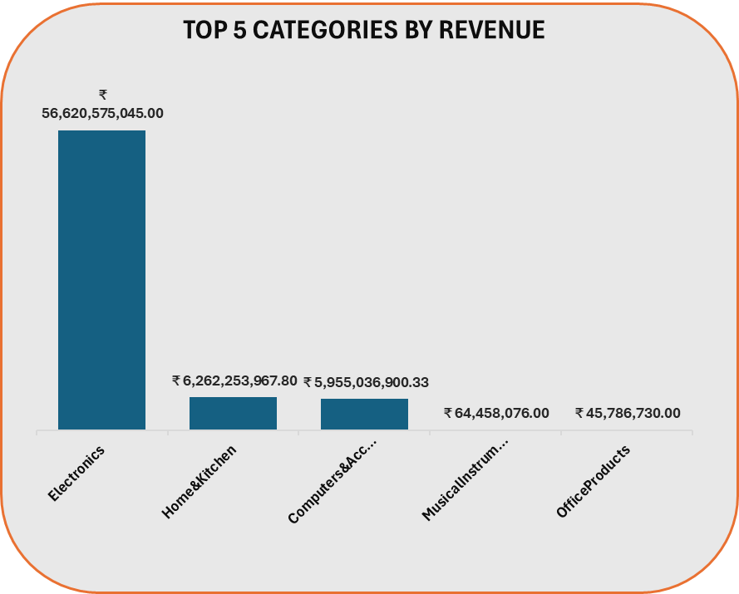

**REVENUE DISTRIBUTION BY PRICE BUCKET**  
The chart illustrates revenue distribution across three price segments: under **₹** 200, **₹**200 – **₹**500, and above **₹** 500. This breakdown helps identify which price range contributes most to overall revenue, informing pricing strategy and target audience focus. Further analysis could explore trends or shifts in consumer preference among these categories.

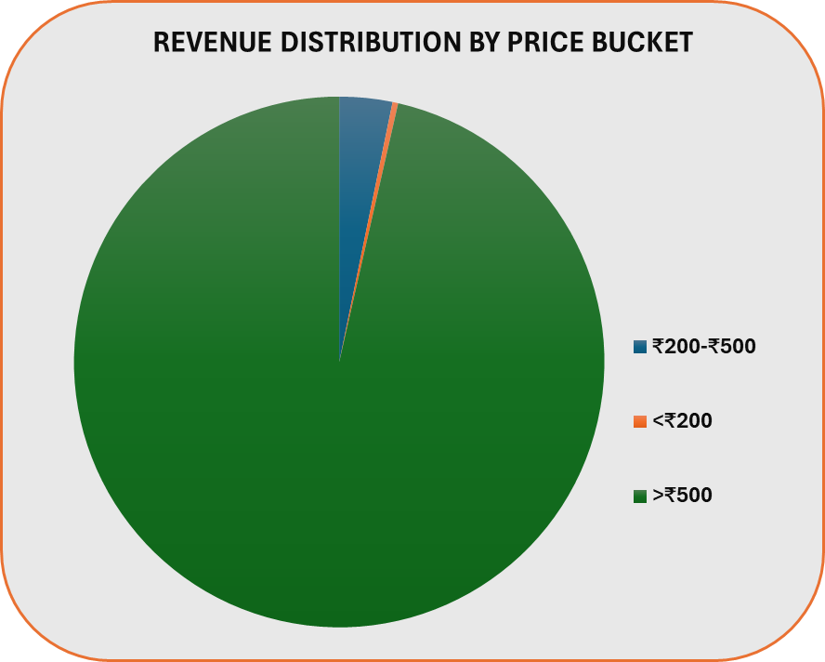

**DISCOUNT% VS AVERAGE RATINGS**

This chart shows a weak correlation. As Discount increases, ratings slightly decrease. But the relationship is not strong, the effect is small. This could be due to product quality, clearance items, or user expectation.

